When K =2, the graph is as follows. The data is clustered into two clusters bastmen with low average and high average bowlers with low and high economy

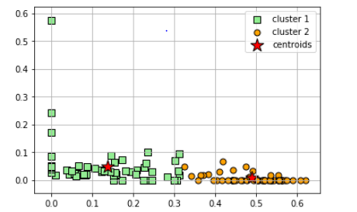

When K =3, the graph is as follows. The data is clustered into two clusters bastmen with low average, medium avearge and high average bowlers with low , medium and high economy

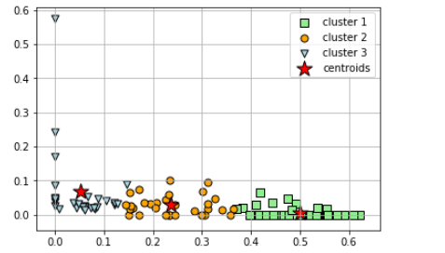

When K = 4, the graph is as follows. The data gives a lot a information. Hence, the data shows batsmens with low and poor batting averages

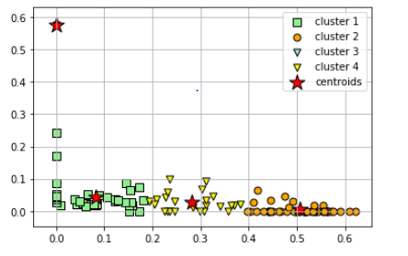

When K = 5, the graph is as follows. The data gives a lot a information. Hence, the data shows batsmens with low and poor batting averages

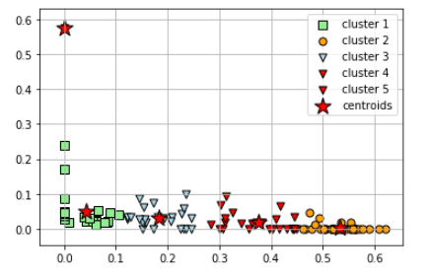

From the data analysed, it is identified that the optimum number of clusters that can be inferred from this dataset would be three.